Requirements
python==3.12.7
numpy==1.26.4
matplotlib==2.9.2
pandas==2.2.3
opencv-python==4.11.0.86
jupyter==1.1.1

Workshop 1
I have chosen to work with the Sales and Satisfaction dataset.
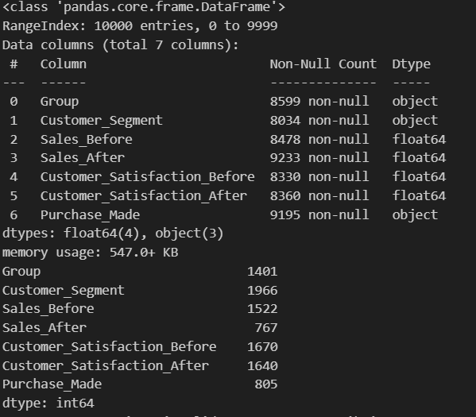
To identify the type of missing data, I first have to explore the data.
I use .info() to see what type of datatype the features are. I then use .isnull() to get a better look at how many missing values there are.
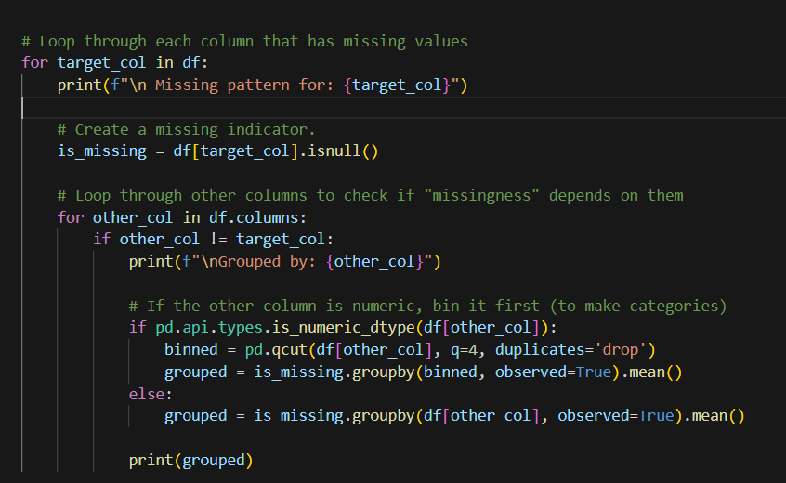
I use this code to find the missing patterns in each column/feature and compare them with all other features. I use .qcut() to sort numerical columns into 4 quantile bins, so it can be compared better with low,,mid, mid_high and high values. I then turn each instance into a Boolean (True or False), which tells if the cell has a missing value. This gives me an output of specific numbers, which when observed, can give an indication if any of the missing data is MCAR(Missing Completely At Random) or MAR( Missing At Random).
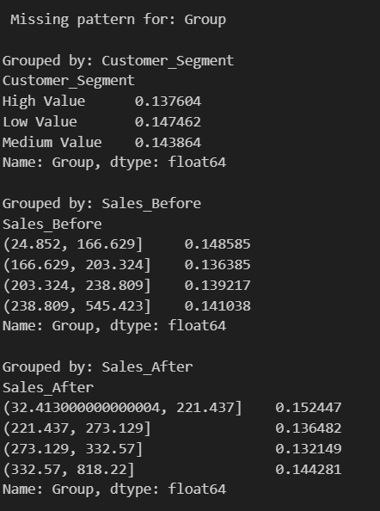
This is just a sample, the real output is for each feature and is much longer. These numbers tell me if there are any patterns in the missingness of the data compared to the other features missing data. The numbers need to differ alot for it to have a high chance of being MAR instead of MCAR, which none of the numbers do, so i can conclude with pretty accurate probability that the missing data is MCAR. Other missing data types would need more domain knowledge, and since this dataset is artificial, it should not be possible to gather that information.

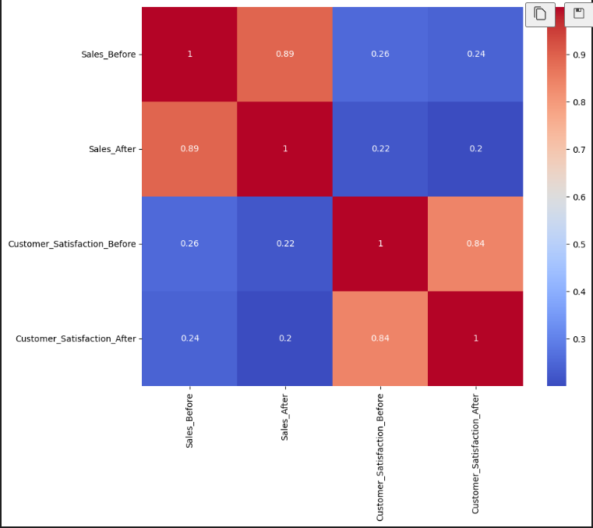
I use a correlation matrix for all the numerical values, to see if there is any good correlation I can use for the imputations. Only things I can indicate is strong correlation between sales_before and sales_after, as they are basically the same thing. Other than that, there does not seem to be that much of a correlation.

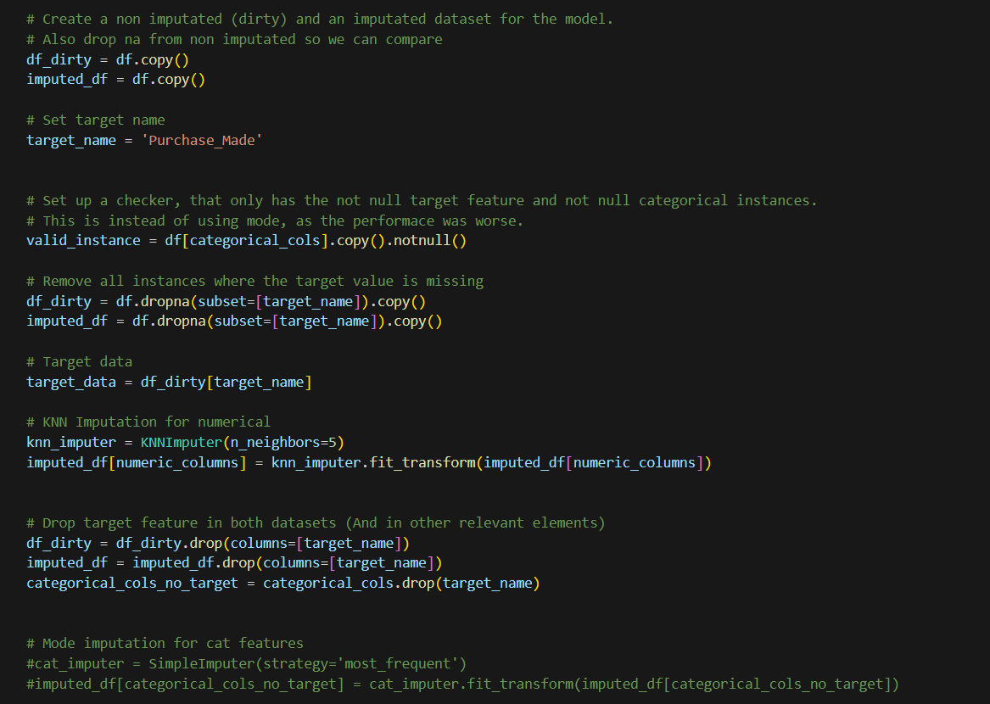
To compare my imputed data with the non imputed data, I create 2 copies of the original dataset, one with imputations (imputed_df) and one with none (df_dirty). I choose the “Purchase_Made” feature as my target for the comparison randomly.
I have chosen to use a KNN imputation method for my missing numerical values, as it is better than mean, but still simple, and should suffice with MCAR. I use 5 for N neighbour’s.
For the missing categorical values, I remove the instances outright, as Mode imputation got me worse results. I then use one hot encoding on the rest, so I can use it in my model later.

I split both datasets with a train on 30%. I choose Decision tree classifier to do the predictions, and create 2 models, one for each dataset.
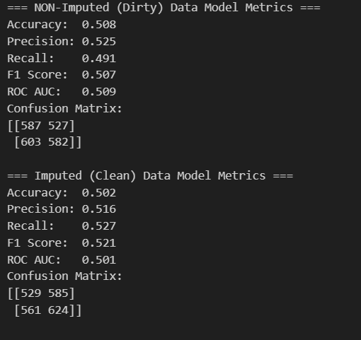
The result show that my model did a horrible job at predicting my imputed data and the non imputed data. It is basically the same as random guessing. This indicates that my model did not capture the patterns of either dataset. I could try with other imputation methods, maybe a model based one, but I am guessing since the data is artificial, and the missing data was MCAR, there is not really any pattern in the data. I could be wrong.
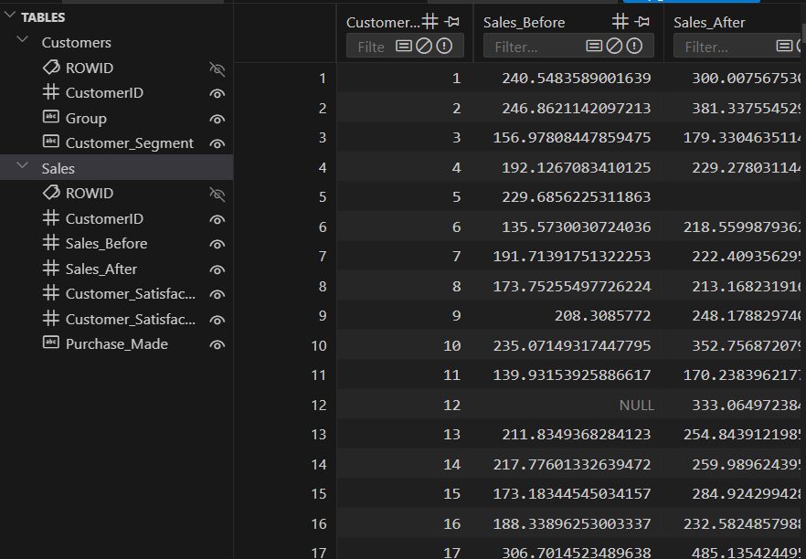
For the rational databases, i used SQLite to create a .db file with 2 custom tables. I used the unfiltered raw data to do this, as my imputation was bad, so it would not matter.
1. A table for the customer, which has a CustomerID that gets placed at each instance, and also the “Group” and “Customer_Segment”.
2. A table for everything “sales” related. This includes the Customer ID, sales_before, sales_after, customer_satisfaction_before, customer_satsifaction_after and purchase made. The file can be found in the github folder.

Workshop 2
I have chosen to use “DJIA 30 Stock Time Series” created by SZRLEE as my primary dataset for the workshop 2 project.
From this file I have chosen to only focus on the stock AABA in the time-zone 2006-01-01 to 2018-01-01 for a more focused perspective.
Therefore, i will only use the file AABA_2006-01-01_to_2018-01-01.csv.
First, I start by getting a visualization of the data by using matplotlib.
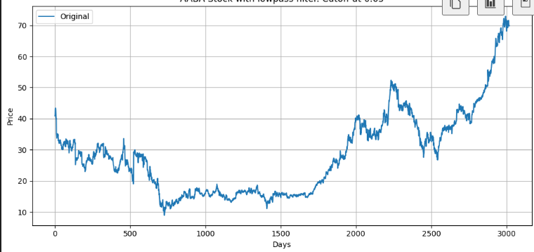
Here we see a lot of sudden spikes. I zoom in to get a better look by taking the first 200 instances/days.
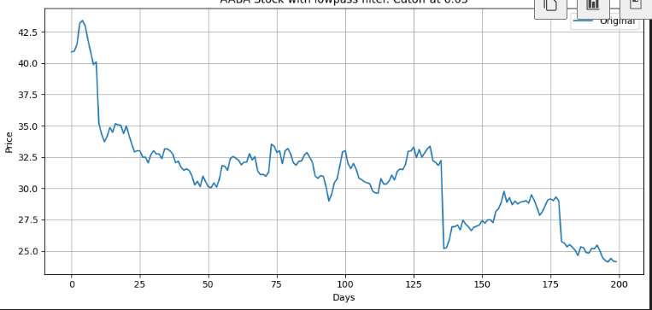
There are many sudden drop-offs, which will make it hard to use the data for real world applications. For example, if I wanted to see how the stocks general movement was in a time zone, its going to be a problem when there is a lot of noise in the dataset. If I were to differentiate day 27, the change would be a couple of cents, but if I were to do the same at day 135 (the big drop in the picture above), there would be a change of multiple dollars.
To get a better understanding of the stock, and how it changes overtime, I am going to use Fourier filtering to remove some of the noise, and smooth out the graph.
First i download the data from kaggle, load it in using pandas. I focus only on the “close” column, as it is the closing price of that day.
I centre the graph around the x-axis, for a better transformation. This is done by taking the mean value of all the instances and subtracting it from the original.
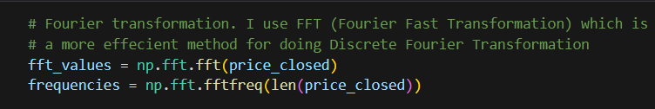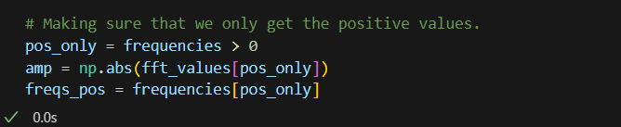
I the use Fourier transformation on the centered data, to get frequencies and the values. I also make sure it is only positive numbers.
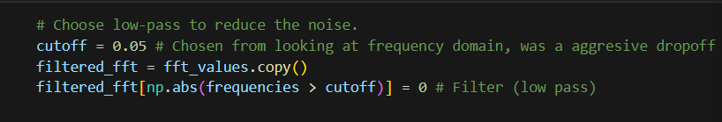
I then plot the frequency domain, so I can select a relevant cutoff point for my filter. I chose to use lowpass filter, as it cuts off the high fluctuating frequencies, which is what im am trying to do.

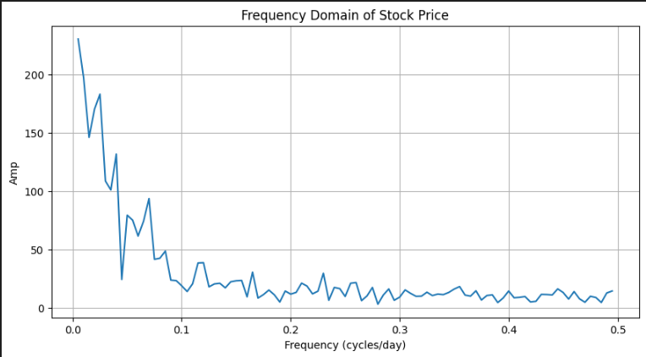

By looking at the graph, we can determine the best cutoff would be in the 0.02-0.05, where the steepest fluctuations happen. I have tried with 0.01-0.05 cutoffs for my data, and by visually observing, concluded that 0.05 is a good cutoff value, as it smooths out the data, but keeps the patterns.
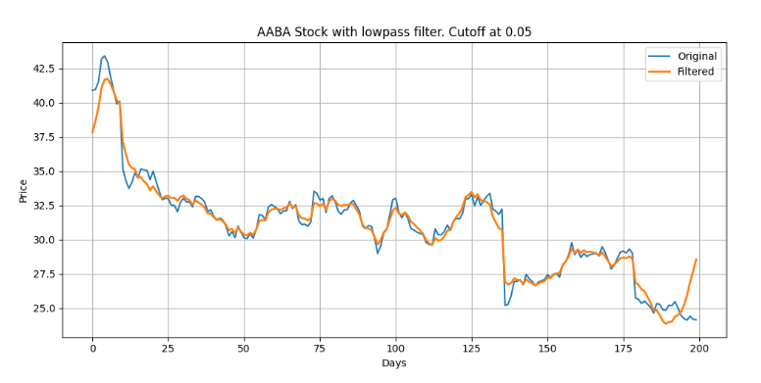
Data with a lowpass filter and a cutoff value at 0.05. Only in the range from 0-200 days.
The data is significantly reduced in noise from the original, but still has the overall patterns.
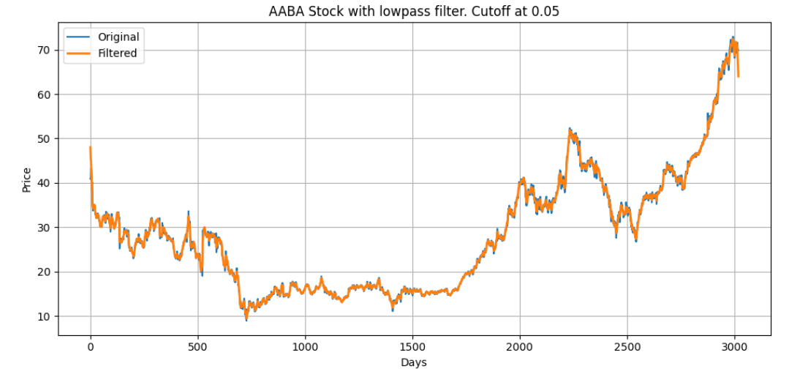
Here is the whole AABA data, with original and filtered values.

